Practice Problems for Module 5

The problems use the intercollegiate athletics database as described in the background document. The course website also contains Oracle and MySQL CREATE TABLE statements as well as INSERT statements.
- List the event number, date held, customer number, customer name, facility number, and facility name of 2018 events placed by Boulder customers.
QUERY :
SELECT EVENTNO,DATEHELD,EVENTREQUEST.CUSTNO,CUSTNAME,
EVENTREQUEST.FACNO,FACNAME FROM CUSTOMER
JOIN EVENTREQUEST ON CUSTOMER.CUSTNO=EVENTREQUEST.CUSTNO
JOIN FACILITY ON EVENTREQUEST.FACNO=FACILITY.FACNO
WHERE DATEHELD BETWEEN '01-JAN-18' AND '31-DEC-18' AND CITY='Boulder';

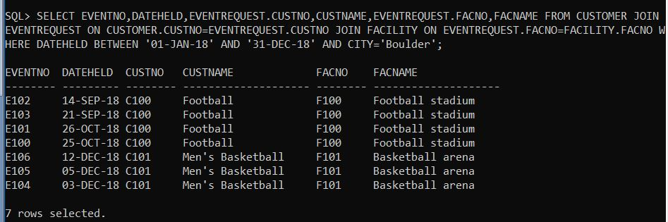

- List the customer number, customer name, event number, date held, facility number, facility name, and estimated audience cost per person (EstCost / EstAudience) for events held on 2018, in which the estimated cost per person is less than $0.2
QUERY:
SELECT EVENTREQUEST.CUSTNO,CUSTNAME,EVENTNO,DATEHELD, EVENTREQUEST.FACNO,FACNAME,ESTCOST/ESTAUDIENCE AS COSTPP FROM CUSTOMER
JOIN EVENTREQUEST ON CUSTOMER.CUSTNO=EVENTREQUEST.CUSTNO
JOIN FACILITY ON EVENTREQUEST.FACNO=FACILITY.FACNO
WHERE DATEHELD BETWEEN '01-JAN-18' AND '31-DEC-18' AND (ESTCOST/ESTAUDIENCE) < 0.2;
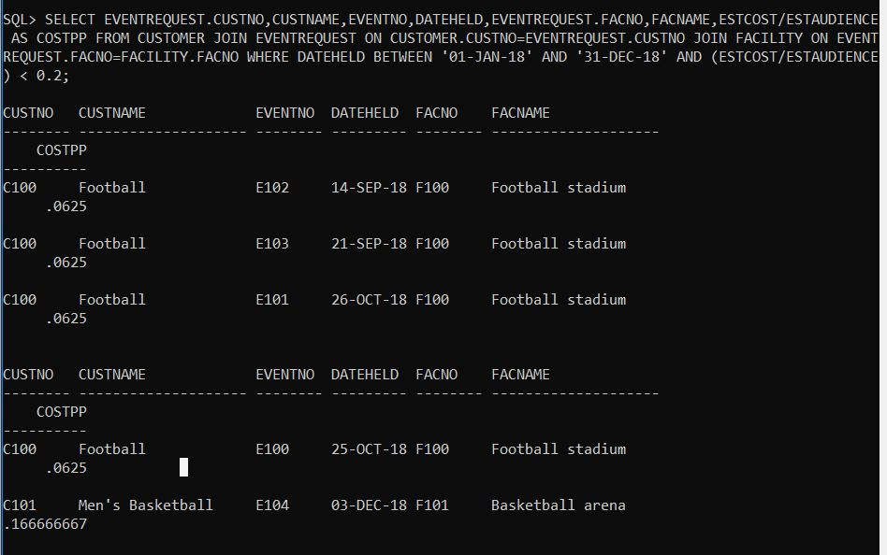
- List the customer number, customer name, and total estimated costs for Approved events. The total amount of events is the sum of the estimated cost for each event. Group the results by customer number and customer name.
QUERY: SELECT CUSTOMER.CUSTNO,CUSTNAME, SUM(ESTCOST) AS TOTALESTCOST FROM EVENTREQUEST
JOIN CUSTOMER ON EVENTREQUEST.CUSTNO=CUSTOMER.CUSTNO
WHERE STATUS='APPROVED' GROUP BY CUSTOMER.CUSTNO,CUSTNAME;
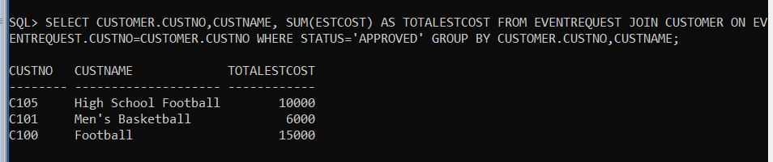

- Insert yourself as a new row in the Customer table.
QUERY:
insert into customer (CUSTNO,CUSTNAME,ADDRESS,INTERNAL,CONTACT,PHONE,CITY,STATE,ZIP) VALUES ('123','SHRAVAN','HYDERABAD','Y','34343','4352345245','RAIDURG','TELANGANA','505001');
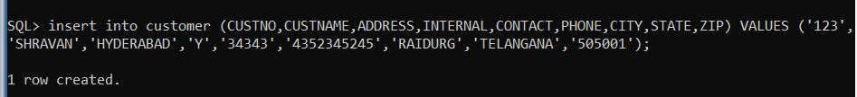

- Increase the rate by 10 percent of nurse resource in the resource table.
QUERY:
UPDATE RESOURCETBL SET RATE=RATE+(0.1)*RATE WHERE RESNAME='nurse';

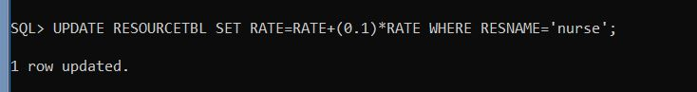

- Delete the new row added to the Customer table.
QUERY: DELETE FROM CUSTOMER WHERE CUSTNAME='SHRAVAN';
